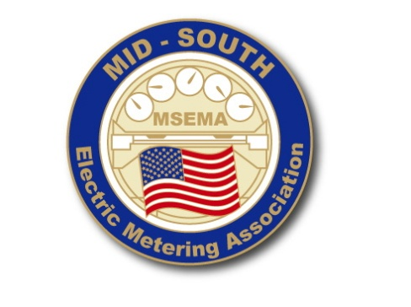
73^{rd.} Annual Electric Meter School and Conference
Embassy Suites, Murfreesboro, TN
May 6-10, 2024
Dear Exhibitor:

You are cordially invited to exhibit at the Mid-South Electric Meter School, sponsored by Mid-South Electric Metering Association and Pellissippi State Community College. This year’s conference will mark the 73rd Annual Mid-South Electric Meter School and will be held May 6-10, 2024, at the Embassy Suites Hotel in Murfreesboro, TN.

Conference hotel information is as follows:

Embassy Suites
1200 Conference Center Blvd.
Murfreesboro, TN 37129
Phone: 800-421-7275

https://www.hilton.com/en/attend-my-event/midsouthelectricmeteringassociationconf2024/

Exhibitors will receive maximum exposure. There will be many opportunities for you to demonstrate your products and services to conference participants: breaks and continental breakfasts will be held in the exhibit area. There will also box lunches in the exhibit area on Tuesday.

We have decided to continue offering the substation course once again this year. We feel that this is an asset to the meter school and have received a lot of positive feedback from it. We anticipate that this course will continue to allow additional utility personnel to attend and obtain excellent knowledge and training through our school. This addition will also allow our exhibit area an expansion to include substation related items along with the metering products. We feel like this will be a great benefit to our school and students.

To register as an exhibitor, please complete the exhibit application and submit with payment using one of the three options provided (including an online application). Exhibit space will be assigned according to the date of receipt of exhibit application and required payment. Exhibitor set up will begin on Monday at 10:00 a.m. Take down will begin at 2:00 pm on Wednesday. Exhibit hours are: Monday 1:00 – 5:00, Tuesday 8:00 - 5:00, Wednesday 8:00 - 2:00

The accompanying reservation form will provide you with costs, dates and other pertinent information about exhibiting in the Mid-South Electric Meter School. If you have any questions you may contact the following people:
Angela Branson
Pellissippi State Community College
P.O. Box 22990
Knoxville, TN 37933-0990
Phone: (865) 539-7167, Mon.-Fri. 8:00 a.m. -4:30 p.m. (EST)
Fax: (865) 694-6583
Email: abranson@pstcc.edu
Doug Roberts
City of Nicholasville
517 N. Main Street
Nicholasville, KY 43056
Phone 859-553-2790
E-mail: doug.roberts@nicholasville.org

Please complete the enclosed exhibit space contract and email to abranson@pstcc.edu today! We are looking forward to having you attend the MSEMA Conference in 2024.

Thank you for your continued participation and support,

Doug Roberts
President, Mid-South Electric Metering Association
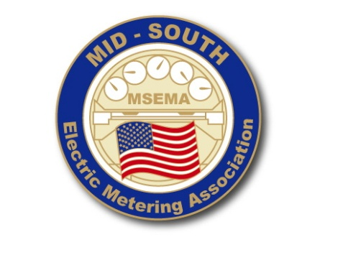
73^{rd.} Annual Electric Meter School and Conference
Embassy Suites, Murfreesboro, TN
May 6-10, 2024

EXHIBITOR RESERVATION AND AGREEMENT

We, the undersigned, do hereby make application for exhibit space as indicated below.

COMPANY NAME: PHONE:

BUSINESS ADDRESS

CITY:_________________________________ STATE: __________________ ZIP: ___________________

(ONE COMPANY PER REGISTRATION)

PLEASE RESERVE _________ TABLE(S) @ $700.00 first table. $75.00 additional table (only one extra table allowed)
($800.00 EACH IF RECEIVED AFTER 4-15-2023)

- REGISTRATION FEE INCLUDES ONE 6’ DRAPED TABLE, REGISTRATION, AND LUNCH FOR TWO REPRESENTATIVES ON WEDNESDAY. ONLY ONE EXTRA TABLE ALLOWED TO BE PURCHASED
- ADDITIONAL REPRESENTATIVES ARE WELCOME AND ARE ENCOURAGED TO ATTEND EXHIBIT AREA AND LUNCH ON WEDNESDAY FOR $35 PER PERSON.
- EXTRA MEAL TICKETS

*NO TABLE SHARING*

Check Enclosed (Payable to Pellissippi State Community College)

Call 865-539-7167 with your credit card. You will still need to email the form.

Online at: https://registration.xendirect.com/pellissippi/searchResults.cfm?couID=1569

c) Create Account, Complete registration form and provide payment. You can email your form

NAME(S) & EMAIL OF REPRESENTATIVES FOR NAME TAGS (PLEASE PRINT):

Name of Representative | Email Address
1.
2.
*We need to know in advance if you have any special requests on regarding the location of your table*

Will you need electricity at your booth? Yes_____ No_____
Will you be attending the Business Luncheon Yes_____ No_____

Exhibitor agrees to keep Pellissippi State Community College & Mid-South Electric Meter School harmless for any damage, loss, cost liability, or other non-program expense associated with the exhibitor’s occupancy and use of exhibition premises.

Signature of Company Official

Mail with payment or fax contract to:Attention: Angela Branson
Pellissippi State Community College
P.O. Box 22990
Knoxville, TN 37933-2299
abranson@pstcc.edu

